**Experiment No. 02**

* 1. **Experiment Name**

Speed control of a DC motor using temperature sensor

* 1. **Objectives**
* To get a better understanding of PLC hardware and the ladder diagram
* To get familiar with the speed control of DC motors and their PLC implementation
* To understand the generation of PWM signal using an Arduino Uno
* To get familiar with the use of the driver circuit and BJT for varying the duty cycle
  1. **Theory**
     1. **Speed control of a DC motor with Arduino UNO code**

A DC motor's speed can be controlled using a variety of methods and by modifying a number of factors such as, power supply, armature resistance, field winding control, pulse width modulation (PWM), and electronic control circuits.

The PWM signal was generated and used to control the speed of the DC motor. Here, the Arduino Uno microcontroller played an integral part for the generation of the PWM signal. The duty cycle of the PWM was adjusted by adjusting the potentiometer. The Arduino detected the resistance and calculated the duty cycle. Then this signal is fed to the DC motor and speed was controlled.

* 1. **Apparatus**
* DC motor
* Oscilloscope
* Potentiometer
* Driver Circuits
* Probe
* Arduino UNO
* Voltmeter
* Ammeter
* center-taped transformer
* Power Diode
* Software
  + Arduino software
  + MATLAB Simulink software
  1. **Connection diagram**
     1. **Driver Circuit connection**

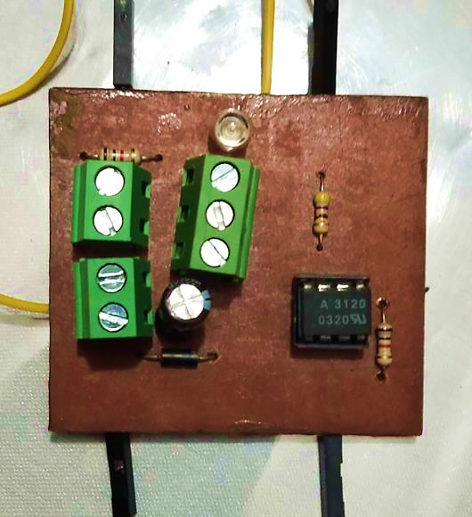

**Figure 2.1:** PCB connection of Driver Circuit

* + 1. **DC motor connection**

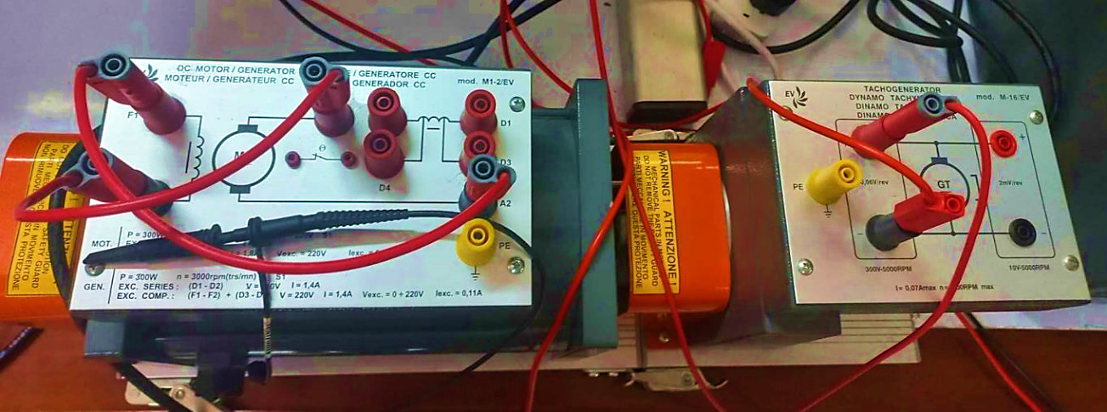

**Figure 2.2:** Experimental connection of DC motor

* + 1. **Experimental connection**

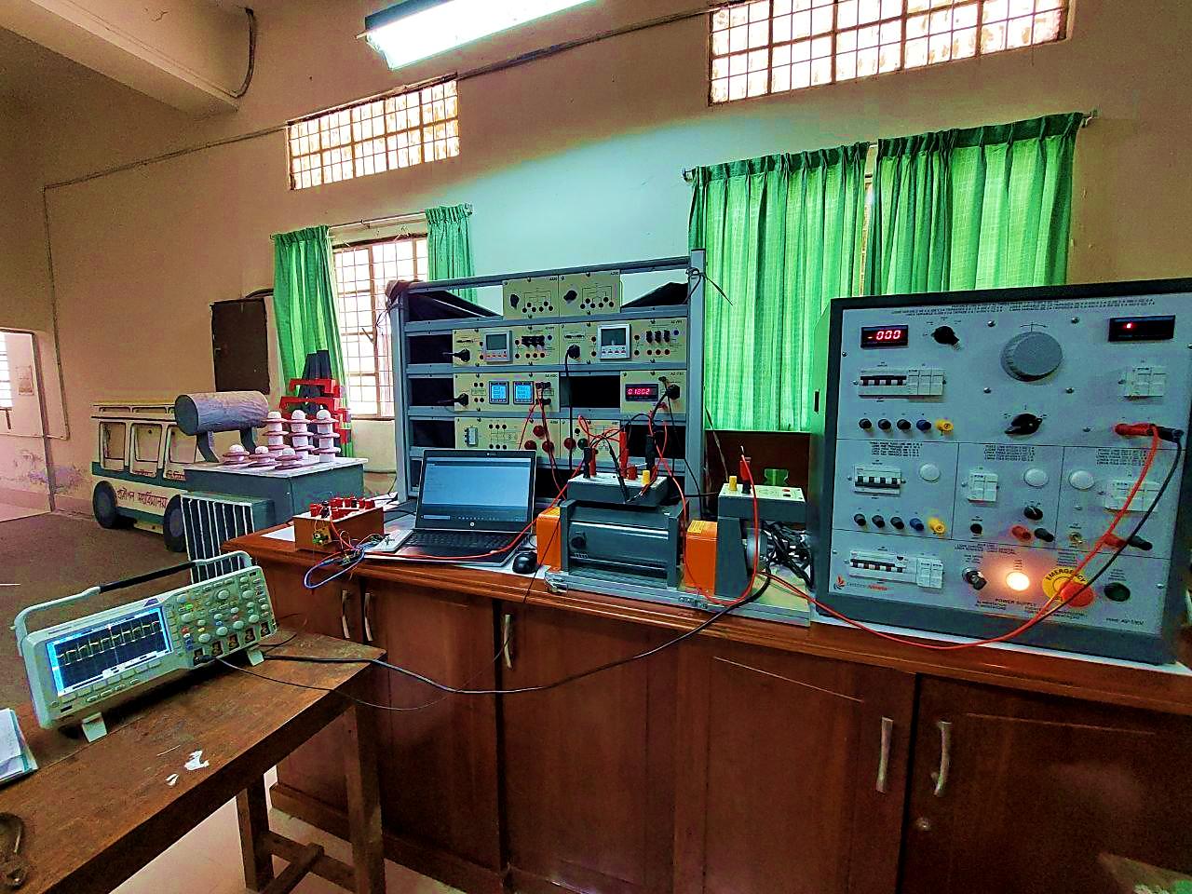

**Figure 2.3:** Experimental setup

* + 1. **MATLAB Simulation**

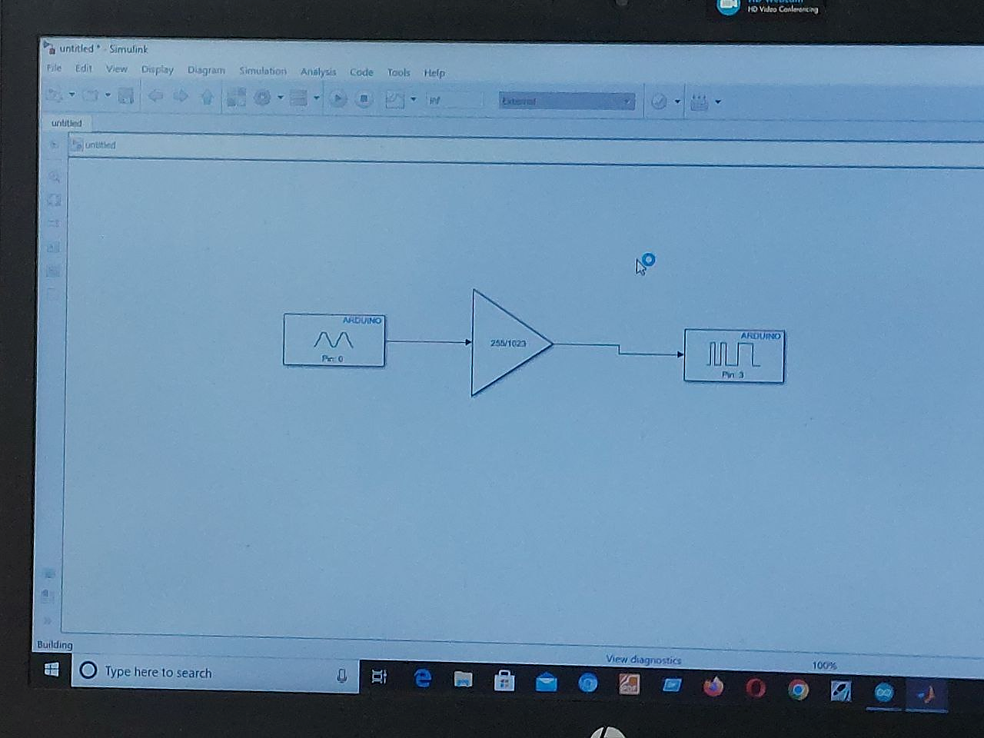 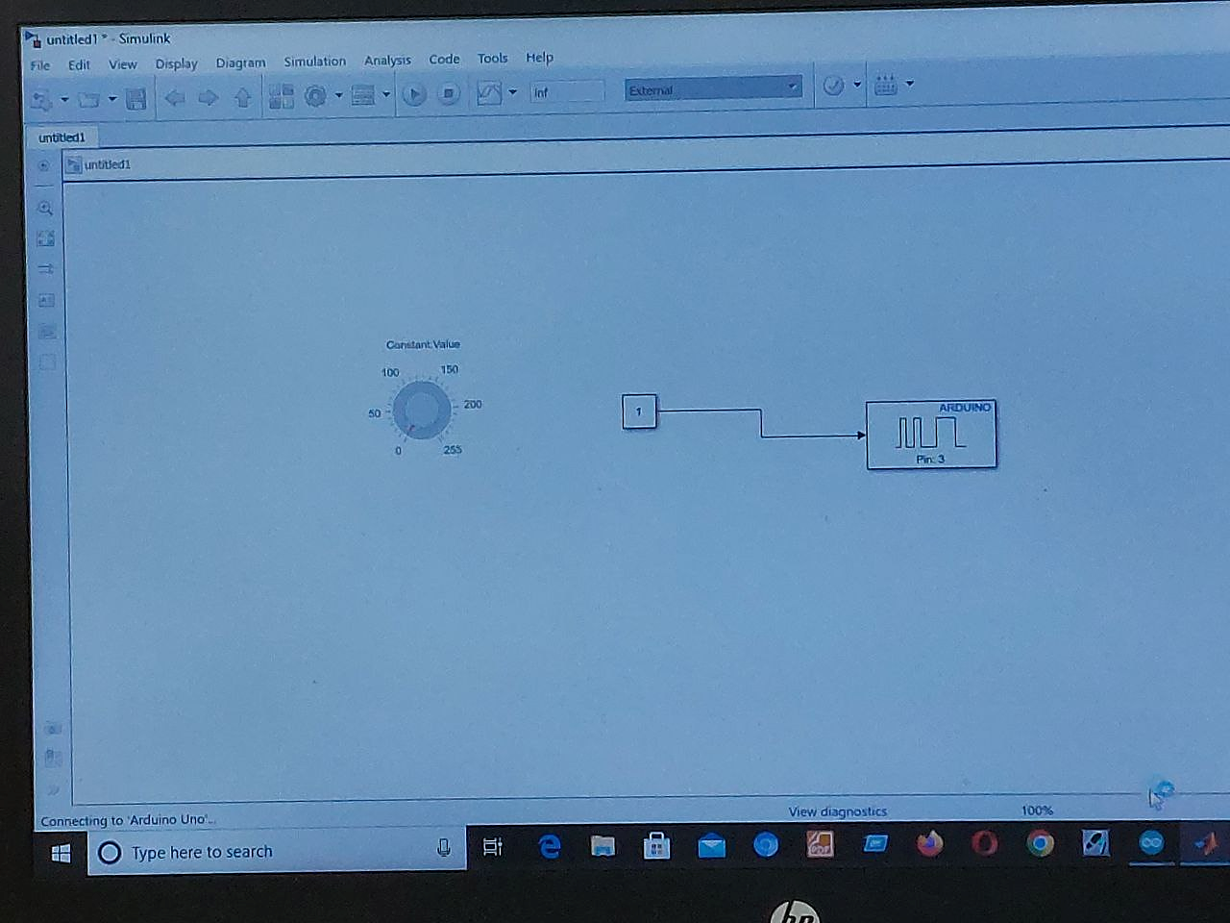

1. PWM generation (ii) Speed control
   1. **Waveform**

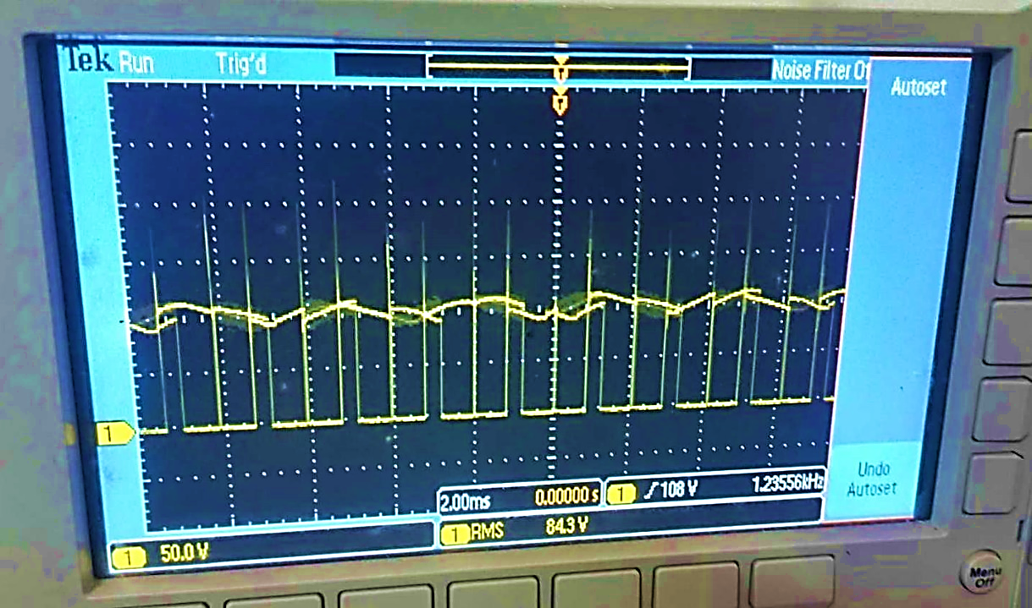

**Figure 1.8:** Experimental setup of OMRON CP1E 40 I/O

* 1. **Discussion & Conclusion**

In this experiment, we designed, implemented, and observed a practical problem, Speed control of a DC motor.

A potentiometer was used to simulate a temperature sensor, with the goal to change the resistance of the potentiometer and the speed of the DC motor. The Arduino was used to generate the desired PWM signal, and the duty cycle was adjusted by changing the potentiometer. This PWM modulated the input signal, and the speed was controlled by feeding the signal to the motor. This worked because the average value of the input signal decreased as the duty cycle decreased, and vice versa.

There were few limitations such as, the potentiometer's response time to resistance changes is relatively slow compared to dedicated temperature sensors. Moreover, the relationship between temperature and resistance is not linear. Real temperature sensors, like thermistors, exhibit a more predictable and accurate response to temperature changes.

As a result, the experiment was a success. This experiment is a basic demonstration of how analog components can be utilized for control. Because of the limits of the potentiometer, it is not a realistic approach for accurate temperature-dependent control.